CYB 220 Project Two

Southern New Hampshire University

2/13/2022

Douglas few

Set an Access Control List so that only the admin network is the only network that can communicate with the FTP server.

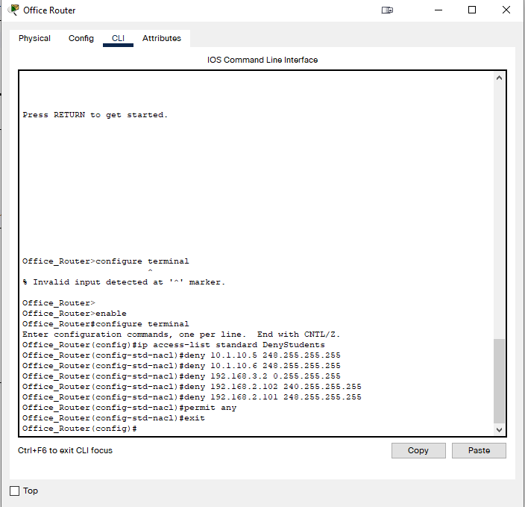

Added users to the FTP server and granted permitted access.

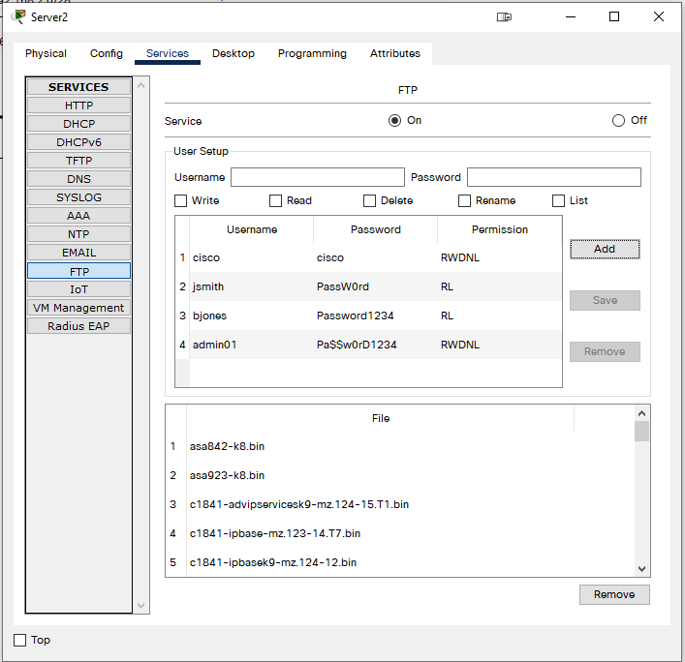

All web traffic originating from port 80 is redirected to the web server.

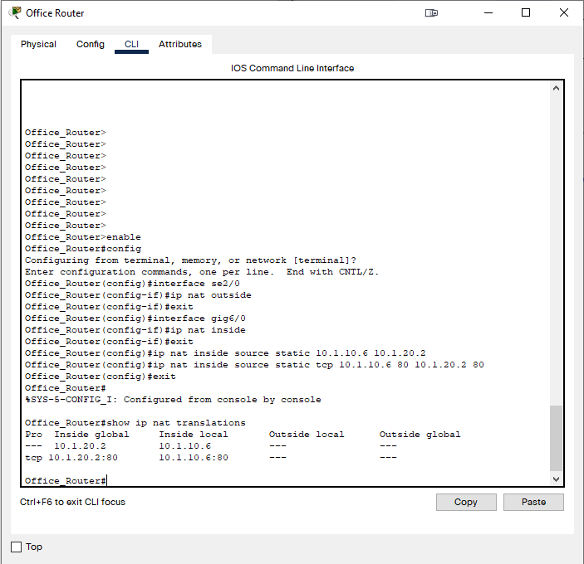

Segmentation

Segmentation is achieved after meeting the host-based firewall configurations by only allowing network administrators to have access to the admin network. This ensures that only authorized individuals can access that section of the network, thereby segmenting it off from the rest of the network for unauthorized individuals. Network segmentation is done for the purpose of controlling the flow of traffic across a network and between subnets on the network based on company policies.

Least Privilege

The principle of least privilege is upheld in a number of ways in this configuration. For one, as mentioned previously, segmenting the admin subnet makes sure that only individuals with adequate privilege can access that section of the network. Furthermore, by setting restrictions and privileges for users on the FTP server, we were able to ensure that the new users “jsmith” and “bjones” only have the privileges of reading and listing content. Meanwhile, the administrator account we added, “admin01”, has privileges for writing, deleting, and renaming content, as well as reading and listing. By doing this, we can ensure that those without the proper training do not manipulate data that they are not authorized to access. Failure to do this could result in lost, damaged, or leaked data which could be detrimental to an organization.

Isolation

By utilizing network isolation, we are able to fulfill what the previous two steps were building towards. By isolating the admin subnet from the rest of the network, we are able to make sure that any task that needs to run on that subnet will be able to be performed without interference from the rest of the network. In other words, no users from outside the admin subnet can access said subnet, making it able to perform more efficiently. On a larger scale, an organization could isolate and segment various sections of its internal network so that each department of that organization can run smoothly on its own subnet. This way, departments won’t have to compete with each other in terms of network traffic and members from outside a certain department with little to no training won’t be able to interfere with the business that department is doing.